#### Application Form - Stock Requisition - Block Level

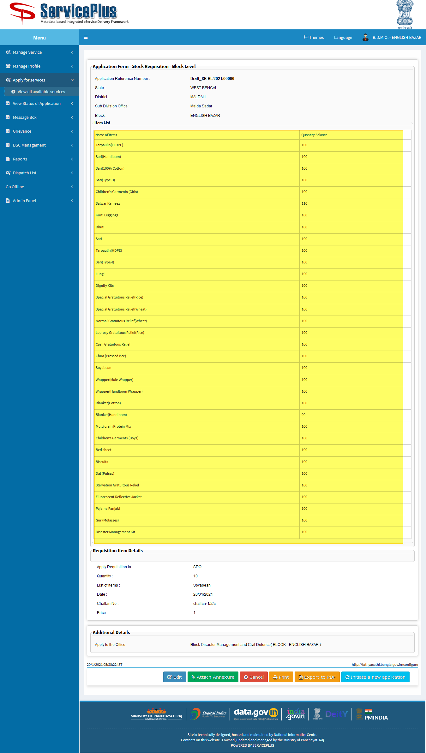

Hide closing balance section

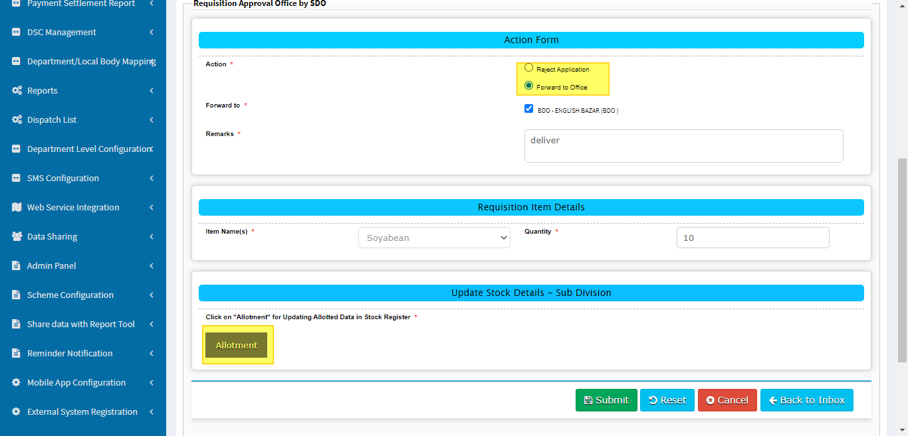

Once allotted hide reject application radio button

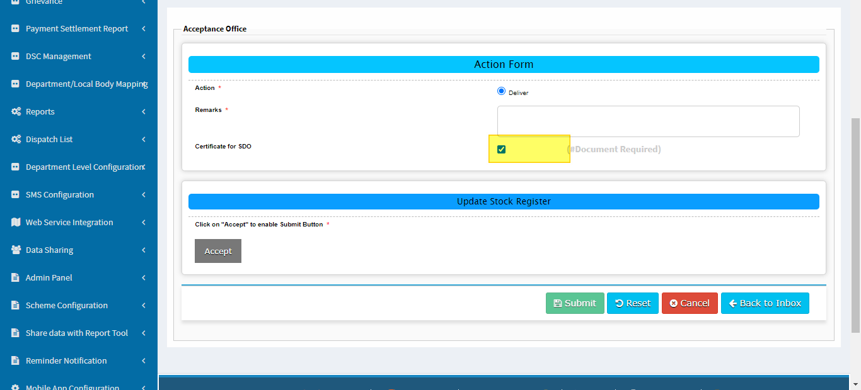

Hide certificate

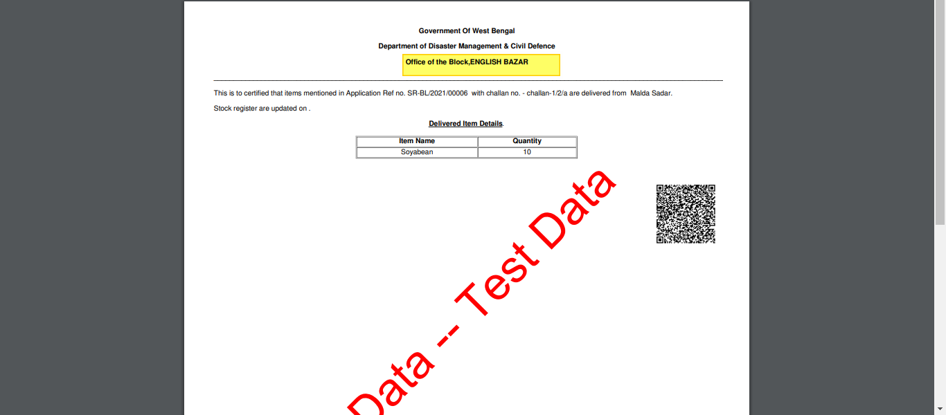

Correct the heading

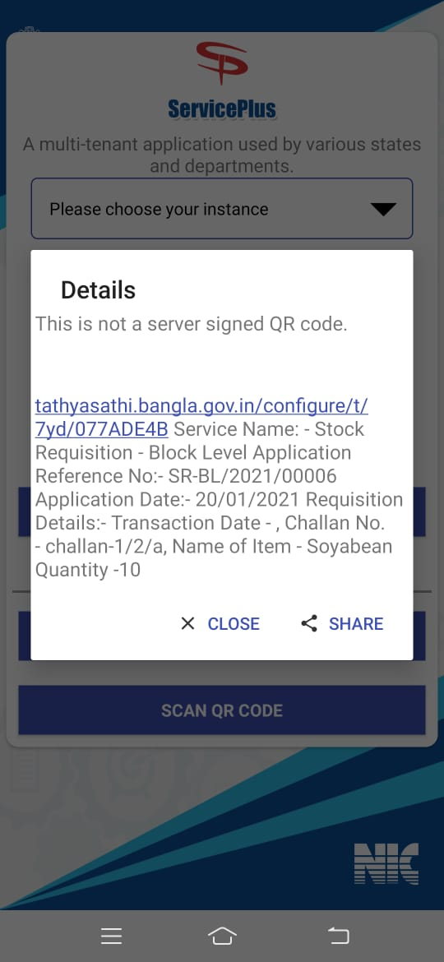

Transaction date not coming.

Separate each data with a comma(,).